If the Shared Drive (P: for some people) Is Not Connecting:

First, try rebooting (please do try this first).

Open file explorer, and see if PIHprojects, 10.10.10.121.29, the P drive is listed below Computer

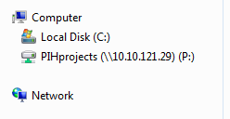

If it is and you cannot connect, see IT.

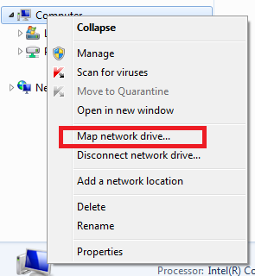If it is not listed, you must map the network drive yourself. To do so:

Right-click Computer and choose Map Network Drive **---------------🡪**

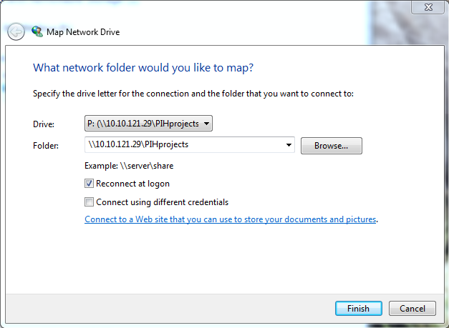

Set the drive drop-down to P

Set the folder to \\10.10.121.29\PIHprojects

Make sure the first check box is checked and the second is not

Click Finish.